LIBRARY SUMMER READING PROGRAM

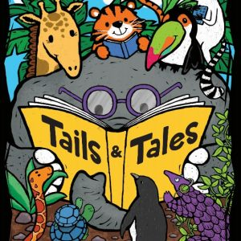
Ready, Set, Go! The Camp Wood Public Library has planned a summer reading program this year beginning the first week of July. Each Tuesday in July, there will be a program beginning at 10:00 am and ending around 11:30 am. The line-up of entertainers looks like this:
Tuesday, July 6 In Lindbergh Park Stories, games, and singing led by library volunteers, finished off with a hot dog lunch
Tuesday, July13 In Lindbergh Park Spikey Mikey, Magician
Tuesday, July 20 At the library Terry Hibbitts, Herpetologist, and his critters
Tuesday, July 27 In Lindbergh Park Diana and John Klebenow, Stargazers
But wait, there’s more! The library will also sponsor a Readathon for elementary school children. Girls and boys may sign up to participate in the Readathon at the first event on July 6. They can check out books from the library and keep track of all the time they spend reading. When they bring their books back to the library, they will be given a ticket for every 30 minutes of time they spend reading. We will collect their tickets at the library, and on Tuesday, August 3 we will meet in the library at 10:00 am. Every child who participates in the Readathon will receive a gift. We will also have a drawing. The children whose tickets are pulled out of the tumbler will win the grand prizes, which are a boy’s bike and helmet and a girl’s bike and helmet for children aged 3 to 6 and a boy’s bike and helmet and a girl’s bike and helmet for children aged 7 to 12.

